ADULT & CHILDREN COMMUNITY SERVICES
OUTREACH, INDEPENDENCE SKILL BUIDLING, BEHAVIOURAL SUPPORT

The services are designed to operate around people’s individual needs, and provide flexible and creative approaches to each young person’s support. We recognise that not one size fits all and aim to find solutions that support individuals and their circle of support by providing opportunities which make sense to all.

Our aim is to develop services which link into the already existing networks of support around people to ensure we have continuity in approach and support, learning and listening to each other to achieve the best outcome for the person

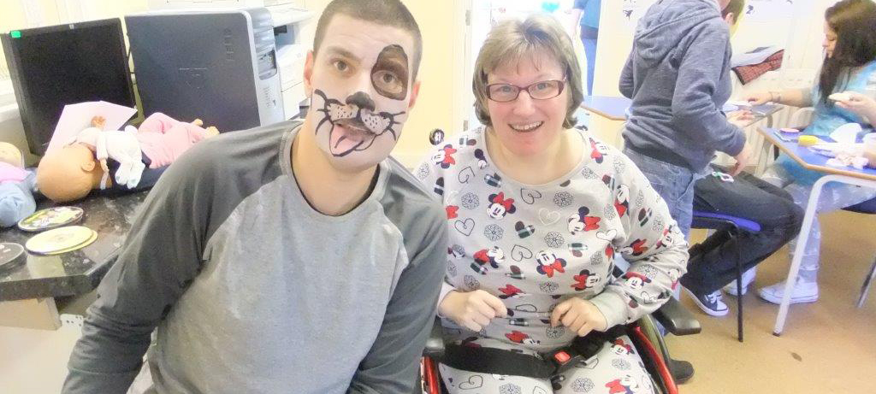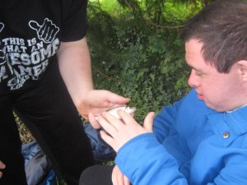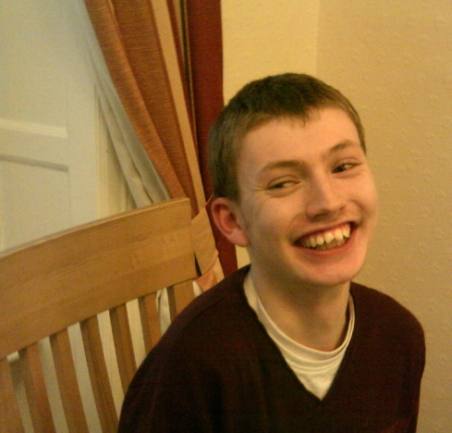

Our services are designed to gives people the ability to take control of their care and support , in a variety of ways which suits them. We aim to ensure that people are supported by a consistent staff team, trained to provide specialist care using a person centred approach, to ensure that people are kept safe, but also are encouraged to make decisions and experience new activities and develop new skills.

DCA Dorset
The agency is currently going through the registration process with CQC to provide personal care to adults and children. The team will be trained specifically to support children and adults with learning disabilities, autism, complex health needs and those need support with managing behaviours through structure and approach.

The agency is based in Ferndown, East Dorset and covers most areas in Dorset through allocated teams in locally based “hub” areas. The service has an on call system for out of hours emergencies and specific safeguarding and complaints policies which are available upon request, in most accessible formats

We aim to be creative in how we support young people, some ideas on how we could support people are:
- One to one support at home or in the community
- Skill building such as learning to cook, personal care, community based
learning, keeping safe in the home or community - based around what you tell us
Support to manage behaviours and develop skills in self regulation
- Medication administration and personal care
- Development of social skills through sessional support using structured approach and planning
- Positive risk management ensuring we support people achieve their outcomes and find solutions to make these happen
- Activities in community, trips away, all planned with person at centre of the support
We believe that everyone is unique, and with their own goals and aspirations. The aim to support people live life to the full and enjoy their support Care and support is completed in a person centred way, putting the person at the centre of what we do. We aim to

How we work

It is important that people are involved in the day-to-day decision making by promoting involvement. We recognise that people with learning disabilities/autism often require support to make informed choices and we do this by working with them and their circle of support to promote their individual communication requirements.

All support will be structured on an individual basis with much emphasis on communication, understanding and participation. The PECS system, widget, communication passports, iPad ‘prologue-to-go’, electronic books, audio and other visual sensory stimulation are widely used within our services.

Effective communication is vital when supporting people with learning disabilities/autism to ensure that there is consistency in approach and behavioural support to ensure that we minimize disruption and anxieties.

About Us
The management team are based locally in Dorset and supported by other social care professionals regionally The Manager has extensive experience working with children, younger adults and their families, educational partnerships and networks of support.

Local contact information
Lisa Jolliffe / 01202-875-404 / 07834-355-109 / lisa.jolliffe@potens-uk.com
Daun Tattersall / 07875-289-849 / daun.tattersall@potens-uk.com

Our staff team are trained to work with children and adults with disabilities, and go through a rigorous recruitment process (using established safer recruitment principals), induction and review, including level 3 safeguarding children training, safeguarding adults training and medication administration.

Some of the specialist training includes MAPA training, attachment theory, TEACCH theory, de-escalation techniques, autism awareness, attachment theory, epilepsy management and emergency medication administration, individual feeding routines. This training is in addition to the mandatory training that is required to support people with their assessed needs

